Goodwill Campaign – Segmentation Series

This is your “bread and butter” Segmentation Series. Unlike the Throat-Grabber, this campaign is designed to be more benefit-rich and content-heavy. It follows the B.D.C. structure (Blind, Direct, Content) so it closes with content as opposed to more overt scarcity.

Email 1: The opening email in this series doesn’t reveal the topic of your Lead Magnet or product, because it is designed to segment out the subscribers on your list who are excited enough about you and your brand to click on your mails without any obvious benefit.

Subj: Kinda weird but very [insert relevant word – ex. “profitable”]
Subj: This flat out WORKS!
Subj: Photo enclosed...DO NOT BEND
Subj: One word...[insert one relevant word or “crazy”]

You gotta see this:

[LINK TO LANDING PAGE]

If you’re on my list, it’s fair to assume you [DESCRIBE INTEREST OR BENEFIT – ex. “...want to play the guitar” / “...want to get more clients” / etc.]

If so, then this is the ideal next step:

[LINK TO LANDING PAGE]

Check it out...

Talk soon,
[YOUR NAME]

Email 2: The opening email in this series should be very direct as to the topic and benefit to segment off the readers on your list who are genuinely excited about the topic covered in your Lead Magnet or product.

Subj: Presenting...[topic / product name / lead magnet name]
Subj: Free Report: [Report Name]
Subj: Free Video: [Video Name]
Subj: Case Study: [Case Study Title]

Have you ever wanted to [INSERT KNOWN DESIRED END RESULT]?

Well now is your chance:

[LINK TO LANDING PAGE]

Recently I [wrote/recorded/rolled out a report/video/training/widget] [about/that does] [DESCRIBE TOPIC/PRODUCT] and I want you to have [a copy/it/one].

You can [access/get/buy] it right now at:

[LINK TO LANDING PAGE]

But do it now while it’s fresh on your mind...

Talk soon,
[YOUR NAME]

P.S. Just imagine, you [DESCRIBE FOR THE READER WHAT IT WILL BE LIKE WHEN THEY HAVE ACHIEVED THE DESIRED END RESULT YOUR LEAD MAGNET/PRODUCT WILL GIVE THEM].

You don’t have to imagine...get it now: [LINK TO LANDING PAGE]

Email 3: This email should be pure content, but it should still be about the topic of your Lead Magnet or product and should link to your landing page inside the content itself, in the P.S. or using an ad or image.

Example 1: Linking within content

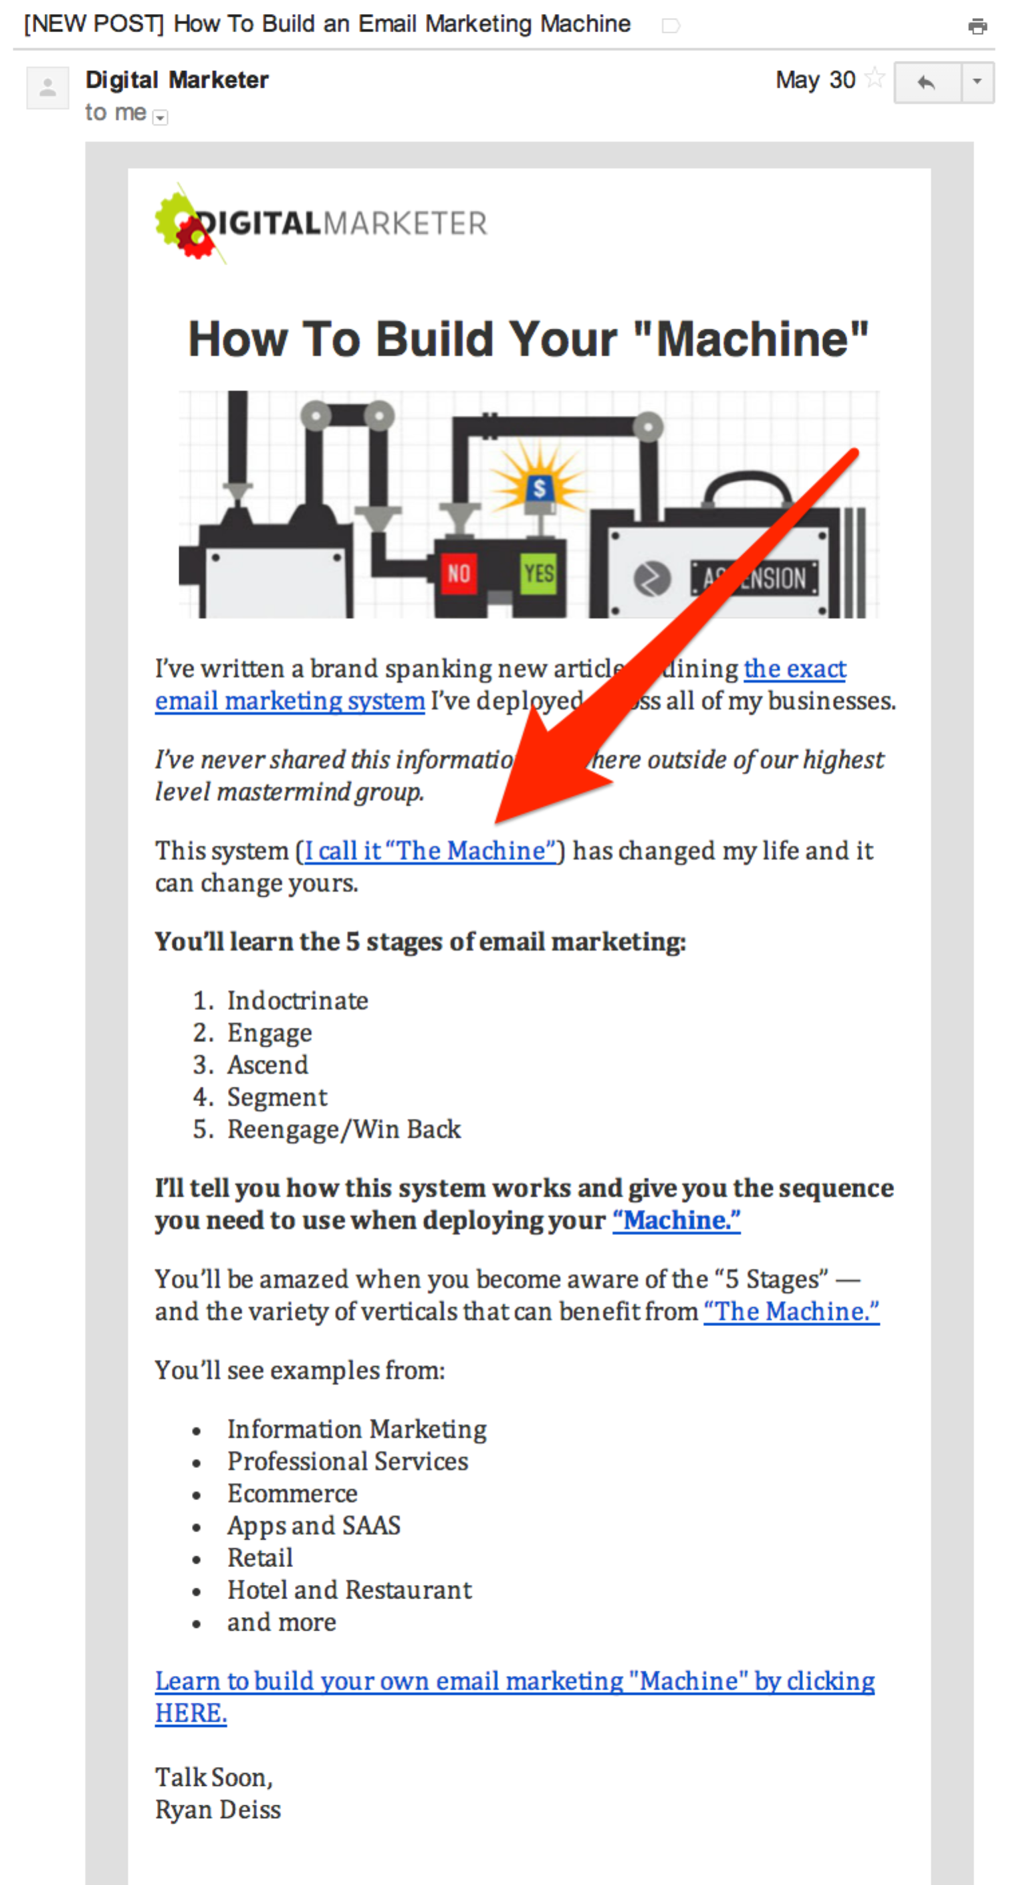

Example 2: Image ad below content

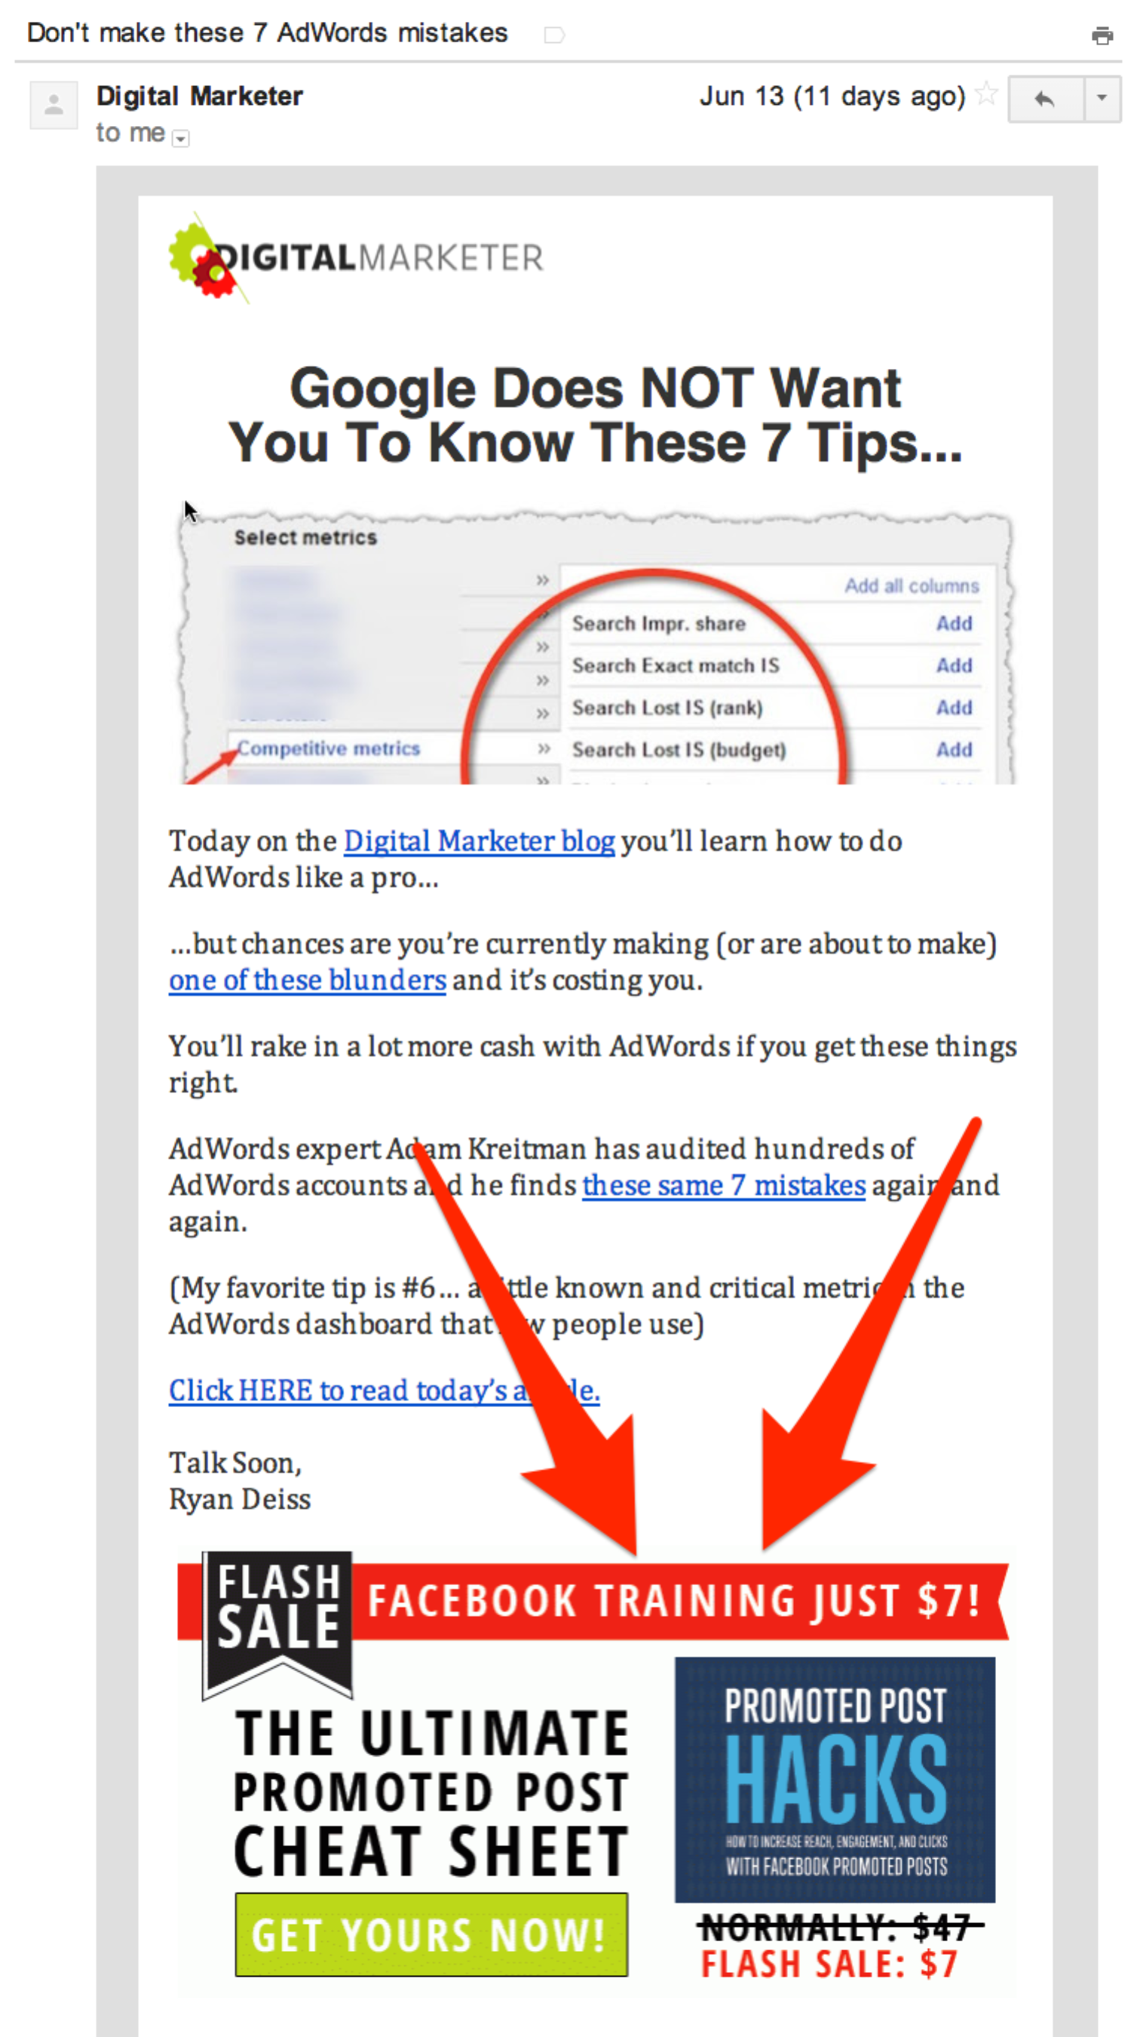

Example 3: Ad block within content

